**RIGPR USER DOC – V1**

Controls

Left Click – Select

Middle Click – Move Map

Menu Screen

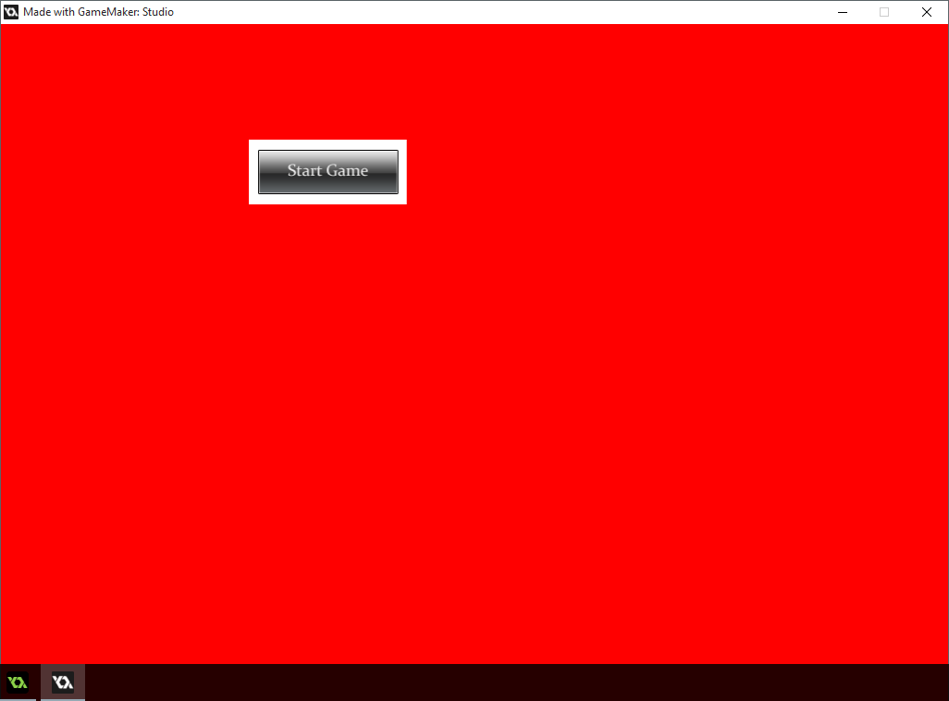

Start Game

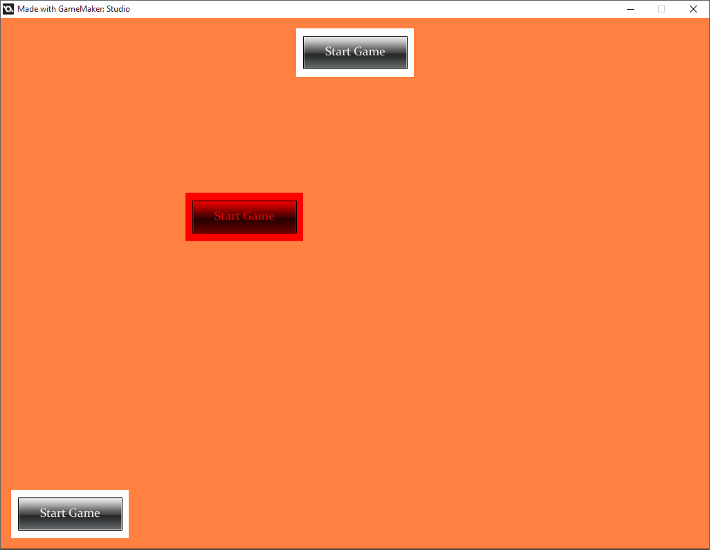

Unused, purely used to show the map does move.

Normal Map Screen

Character Screen

Mythical Map Game

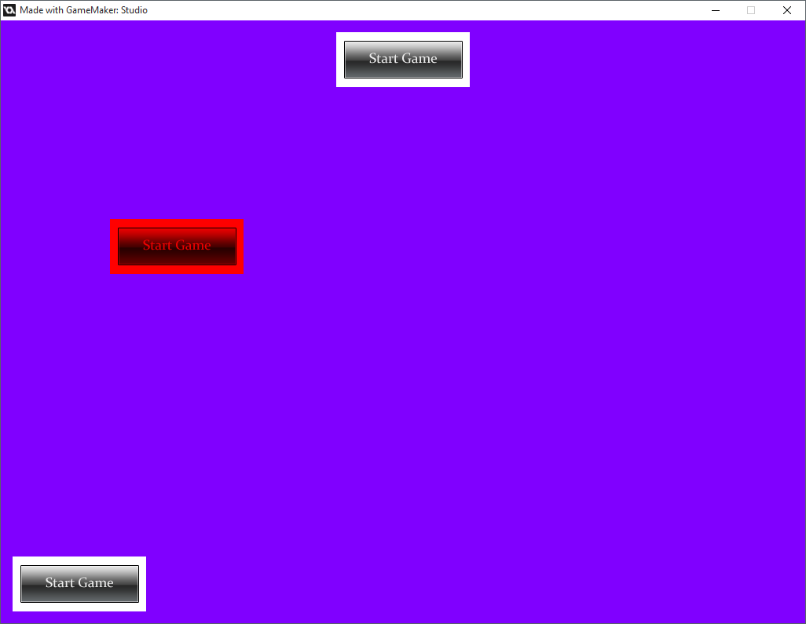

Unused, purely used to show the map does move.

Character Screen

Normal Map Game

Mythical Map Screen

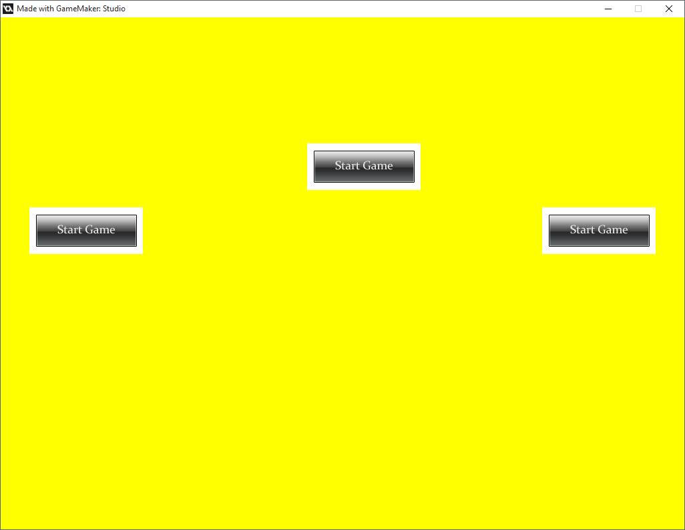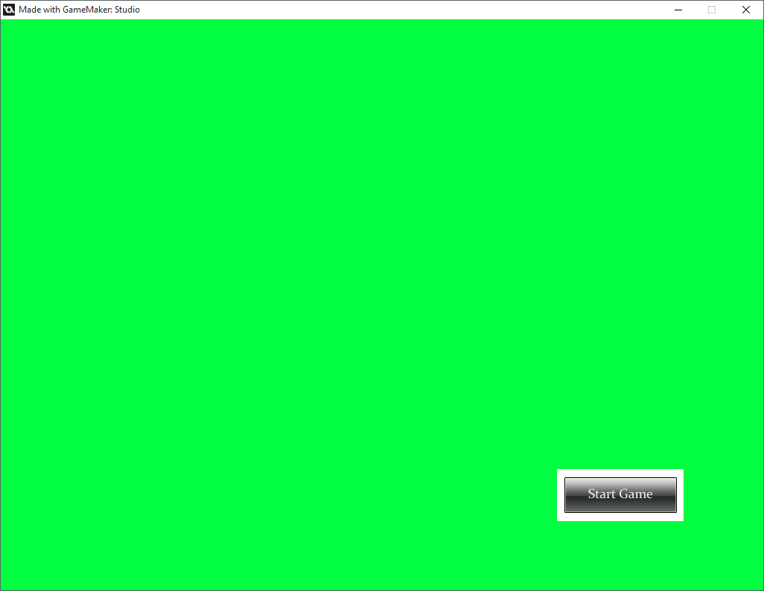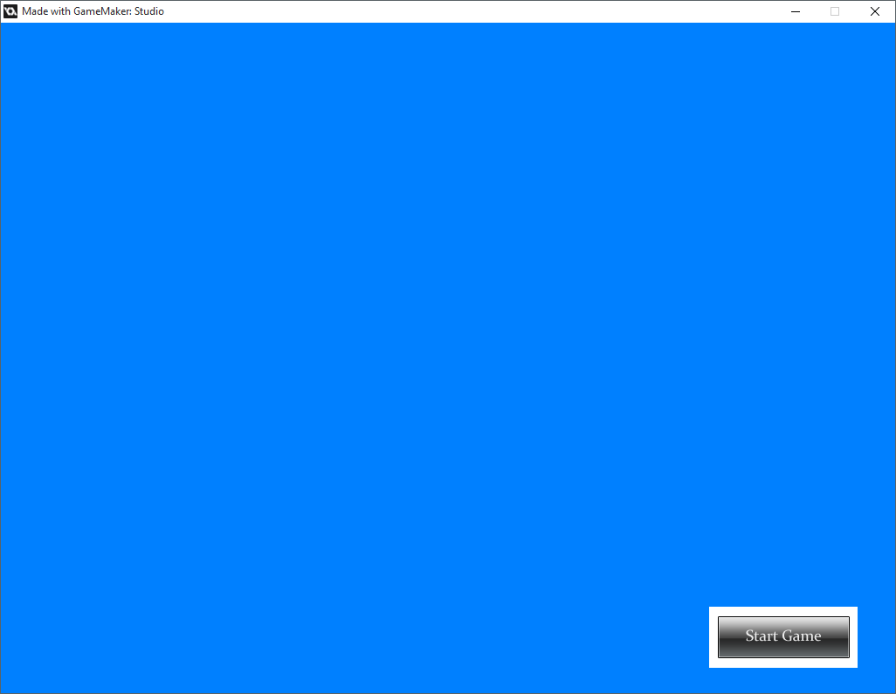

Back to Map

Character Screen

Diary Screen

Character Screen

Back to Character Screen

Diary Screen

Back to Character Screen

Card Screen